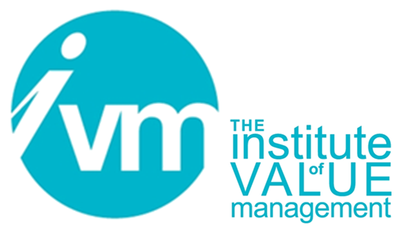

Certification Board

European VM Training and Certification System (Rev 2)

CONTROLLED DOCUMENT

The Institute of Value Management is a Company limited by guarantee. Registered in England No 3798199
Registered Office: Unit 19, The Manor, Main Street, Tur Langton, Leicester, England, LE8 0PJ

Document Control
Title | CB 103 VM Training and Certification System
Person Responsible | Administrative Secretary
Date last updated | November 2019
Status | Draft
Version | V15.5.3
This document is the property of the IVM. It shall not be reproduced in whole or part nor disclosed to a third party. © Copyright 2010 IVM

European VM Training and Certification System
The primary purpose of the current edition of Value for Europe (V4E) European VM Training and Certification System (TCS) is to improve European competitiveness by underpinning the dissemination and development of consistent approaches to Value Management across Europe. The System seeks to realize this purpose by:
- Establishing standards of competence in the application of Value Management (VM);
- Specifying learning objectives and outcomes that underpin that competence;
- Relating those learning objectives and outcomes to an integrated learning structure which includes a family of training courses;
- Creating and implementing a certification process for assessing competence and awarding qualifications to those with demonstrated competence; and
- Setting standards of practice which are consistent across Europe, regardless of the country in which the expertise is acquired.
The scheme is designed to meet the needs of three primary groups:
- Management and staff who are seeking awareness of Value Management.
- Practitioners, who intend to apply Value Management.
- Trainers and staff in higher level academic establishments who wish to help others develop competence in VM.
The System is based upon current version of the European Standards in Value Management (EN 12973, EN1325 and EN16271) as such this is the first internationally integrated Value Management training and certification system in the world. It will make it easier for global organisations to have a common value-based approach to increase their competitiveness.
This document sets out the requirements for the 3 qualification levels under V4E TCS these are:
- Qualified Value Analyst (QVA);
- Professional in Value Management (PVM); and
- Trainer in Value Management (TVM).

The requirements for gaining qualifications:
- Qualified Value Analyst: To gain QVA a candidate must attend an Institute of Value Management (UK) – Certification Board (IVM-CB) accredited VM1 course, apply for the QVA qualification through the Institute of Value Management (IVM) (www.ivm.org.uk) and sit a multiple choice QVA examination at the end of the third day or arrange to sit the exam separately through the IVM Secretary and the respective Trainer. Following attendance on the course and success in the examination, the candidate must provide evidence of personal learning and achievement in the workplace through participation in two value studies to the Certification Board (CB), one of which could have been part of the VM1 course.
The competences to be demonstrated by the candidate in their application are to be able to:
- Explain the principles of and promote Value Management;
- Apply specified Value Management tools independently;
- Contribute to the performance of a value study team.
- The specified core Value Management tools are:
- Preparation for study;
- Root cause analysis;
- Objectives Hierarchy;
- Function analysis;
- Function diagrams;
- Cost to function analysis;
- Idea generation
- Idea categorisation and development;
- Decision building;
- Proposal selection and development; and
- Presentation.
Note that in Value for Europe the word ‘apply’ does not imply proficiency or mastery of the subject – The term ‘apply’ is indicative of a medium level of skill. The learner must have analytical and synthesis skills and abilities and be able to evaluate data and processes so that the learner can select appropriate tools and responses.
The qualification QVA is only granted after independent assessment by the nominated CB assessors. The process for evaluation (AWARD or not) is based on the assessment of evidence supplied and self-certified by a candidate with their application.
The QVA qualification from the IVM Certification Board, the National Certification Organisation (NCO) in the UK, is normally granted without interview.
Application for QVA should be made using form CB107.
- Professional in Value Management:
To gain PVM a candidate, via the normal route, must have completed a 3-day VM1 course, provide evidence of participating in two value studies and undertaken development post their attendance at the VM1 course, then have completed a 3day VM2 course. Following completion of the VM2 course, the candidate should undertake personal development through research or practical experience prior to completing a 3-day VM3 course. The candidate, having completed VM1 to VM3 courses including evidence of participating in two VM studies preferably between VM1 and VM2 courses, will need to, lead and facilitate at least two VM studies following the VM3 course.
Whilst there is NO MINIMUM experience requirement for a candidate who is following the normal route, it is expected that any candidate will demonstrate their competence through learning and achievements over at least 400 hours practical experience across a range of value management activities. Candidates can apply for the PVM qualification through the IVM at (www.ivm.org.uk).
PVM applicants will submit their application form and evidence “a dossier” drawn from practical workplace activity and then attend a formal CB “peer jury” interview with two IVM Certification Board assessors. The applicant must demonstrate competence through learning and evidence drawn from practical workplace activity. If successful, in fulfilling all the requirements, the candidate will then be awarded their PVM qualification from the IVM Certification Board, the National Certification Organisation (NCO) in the UK.
Application for PVM following the Normal Route should be made using form CB108.
PVM for Mature Candidates
There is also a mature candidate route for those without formal VM1, VM2 and VM3 course certificates but who have at least 5 years’ in-depth experience of practicing Value Management and wish to apply for the PVM qualification. A mature candidate will need to demonstrate considerable VM competence-based experience presented in “a dossier” and will attend a formal “peer jury” interview with two IVM Certification Board assessors.
Application for PVM following the Mature Route should be made using form CB109A.

Application through Reciprocity with SAVE International
A reciprocity agreement has been established between the V4E Board and SAVE International for a person holding a CVS qualification from SAVE International to apply for the PVM qualification. There is a requirement that a candidate applying through this route should be able to demonstrate additional knowledge relating to the application of VM at strategic or organisational level or attended a V4E VM3 Course. Candidates will require an “Endorser” from SAVE International. A similar facility exists for a PVM to apply to SAVE for the CVS qualification.
Application for PVM following the Normal Route, from a CVS, should be made using form CB110.
The competences which must be demonstrated, under both routes, are to be able to:
- Determine stakeholder needs and their organisation and cultural context;
- Design studies and assist in Value Management program design;
- Demonstrate promotional skills in a single business context through the application of negotiation, and persuasion;
- Work with teams outside a workshop environment;
- Work with teams in a conventional or virtual workshop;
- Apply Value Management or elements of Value Management independently;
- Report and present results, and promote Value Management;
- Implement and/or support teams to implement results; and
- Ensure that Value Management learning and development is embedded in an organization.
Candidates who wish to apply through the mature route are required to demonstrate recent (within past five years) practical experience of applying and leading others to apply the following value management tools:
- Preparation for study;
- Root cause analysis;
- Objectives hierarchy;
- Function analysis;
- Function diagrams;
- Cost to function analysis;
- Idea generation;
- Idea categorisation and development;
- Decision building;
- Proposal selection and development;
- Presentation;
- Functional Performance Specification;
- Creativity approaches;
- Business planning and business case development;
- Risk - identification, assessment and response;
- Decision management – influence diagrams, decision trees, scenarios; and
- Soft systems methodology.

Candidates should also be able to apply additional methodologies applicable to their industry including:
- Design to cost and performance, Design to objectives;
- Discounted cash flow;
- Whole life cost and value;
- Kaizen;
- Lean;
- Total Quality Management;
- Six Sigma; and
- etc.
The applicant must demonstrate competence through learning and practical experience. If successful, in fulfilling all the requirements, the candidate will then be awarded their PVM qualification from the IVM Certification Board, the National Certification Organisation (NCO) in the UK.
- Trainer in Value Management.
An applicant must have attended a Train-the-Trainer (TTT) course to gain the Trainer in Value Management (TVM) qualification. THERE IS A MINIMUM level of practical experience expected of at least 1000 hours which demonstrates competence at PVM level in leading a wide range of value management activity prior to applying to attend a Train-the-Trainer (TTT) course).

Application for attendance at the TTT course should be made using CB116A.
The competences which are required to be demonstrated by a candidate in their application are to be able to:
- Translate Value Management knowledge into a learning environment;
- Assess training needs;
- Design learning experiences/training courses;
- Develop learning material using a range of learning methods;
- Deliver training material which complies with V4E(2) Training and Certification System;
- Assess performance and provide feedback; and
- Mentor learners.
- Re-certification of PVM and TVM Qualifications
As the system is competence based, PVM and TVM qualifications are granted for a 4-year period. Every 4 years, the NCO must recertify individuals to ensure competence has not only been maintained but, that there is evidence of continued professional development. Please note, in order to retain a TVM qualification an individual must also retain a PVM qualification. There are no recertification requirements for QVA.
- IVM Continued Professional Development
It should be noted, that anyone can apply for membership of the Institute of Value Management (IVM) and there any various grades of membership, please see the IVM website for details. Membership of the IVM requires individuals to undertake Continued Professional Development, to keep an annual log (January to December each year) from commencing membership and may be called upon by the IVM Executive to submit their CPD log for review. This CPD log can be used by PVMs and TVMs to assist in their re-certification process.
- Course Timescales:
VM1: A candidate is required to provide evidence of participating in 2 value studies, one of which could be part of the VM 1 course and one ideally following their successful attendance at a three-day VM1 course and passing the QVA multiple choice examination and prior to applying for becoming a QVA.
VM2: Ideally there should be a gap between attending these two courses(VM1 and VM2) to allow for consolidation of knowledge and gaining some experience in the Value Management methodologies, but as this is not mandated, a candidate could attend the two courses back-to-back but only where the applicant can evidence they have the necessary experience and competence in the core methods and other Learning Outcomes relating to VM1 .
VM3: Following attendance at a VM2 course, a candidate should undertake personal development of at least 3 months, prior to attending a VM3 course and therefore should not attend VM2 and VM3 courses ‘backto-back’. A candidate applying for their PVM must have 400 hours of experience (this is recommended not mandated) post successfully completing their VM3 course.
Train The Trainer (TTT): The TTT course is designed for individuals who wish to design and deliver the suite of training courses leading to a European qualification in Value Management. Prerequisites for acceptance on this course are that all competences required for a PVM have been demonstrated as an entry requirement to TVM, and that those competences have been developed through experience.
A candidate for a TTT course must have a minimum of 1,000 hours of experience of Value Management prior to applying to attend a TTT course. Applicants will find prior experience of training needs analysis and training delivery beneficial. The Trainer running the TTT course should submit a copy of a completed CB116A form for each applicant to the NCO course prior to holding the TTT course. Where an applicant does not hold a PVM qualification, details of the assessment of competence and experience should be submitted to the NCO prior to accepting the candidate onto the TTT course
A further 200 hours of experience is required post attending the TTT course before a candidate should apply for qualification as a TVM. Note to obtain the TVM qualification an individual must also be a PVM.
The decision on the award of qualifications rests with the IVM Certification Board as the National Certification Organisation for the UK.
Trainers can decide who to accept on any course and on the timing and sequence of training provided it complies with Value for Europe (V4E) Training and Certification System. At TTT level there are specific time related minimum entry requirements. Candidates who do not follow the V4E training and certification system
Course availability
All courses are provided by approved and registered trainers in Value Management a list of the trainers and a training diary is provided on the IVM website at www.ivm.org.uk.
If you need advice on how to proceed with an application please contact the IVM CB secretary at secretary@ivm.org.uk
Diagram of the V4E Training and Certification process is shown on the next page:

Diagram of the V4E Training and Certification process
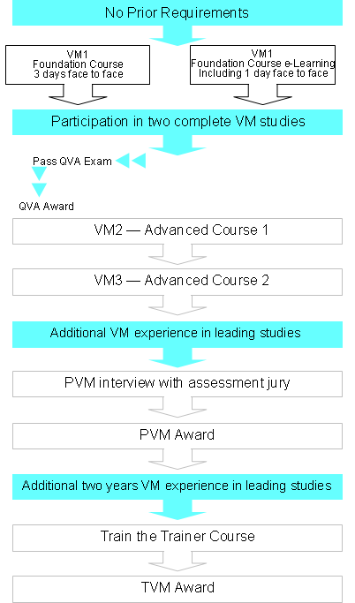
Practical experience and personal development
VM1
Module 1 course
3 days face to face
VM1
Module 1 course e-Learning
Including 1 day face to face
VM2 - Module 2 Course - 3 days face to face
VM3 - Module 3 Course - 3 days face to face
Train the Trainer Course - 3 days face to face

