APPLICANT NAME:

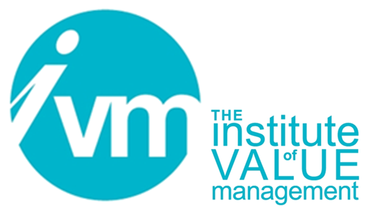

Certification Board

APPLICATION FOR THE QUALIFICATION:
PROFESSIONAL IN VALUE MANAGEMENT (PVM)
UNDER THE VALUE FOR EUROPE BOARD – SAVE INTERNATIONAL
COLLABORATIVE AGREEMENT
CVS HOLDERS ONLY

CONTROLLED DOCUMENT

The Institute of Value Management is a Company limited by guarantee. Registered in England No 3798199
Registered Office: Unit 19, The Manor, Main Street, Tur Langton, Leicester, LE8 0PJ

Document Control
Title | CB 110 Application for the Qualification:  Professional in Value Management (PVM)  through reciprocity with SAVE International
Person Responsible | CB Chair
Date last updated | October 2019
Status | Final
Version | V110.2.5
This document is the property of the IVM. It shall not be reproduced in whole or part nor disclosed to a third party. © Copyright 2010 IVM

SECTION 1 – Applicant’s details

Title and Name:

Contact Address:

Phone: Mobile:

E mail address:

CVS certificate number: Date CVS awarded:

CVS Expiration date:

SECTION 2 – Endorsement and advisor details

Name of endorser:

Position of endorser within SAVE:

Contact e mail of endorser:
I support this application and confirm the validity of information supplied.

Signature of endorser: Date:

Name of advisor(optional):

Contact e mail of advisor:

SECTION 3 – Understanding the European Standard
I affirm that I have read the EN 12973 European Value Management Standard and related EN 1325 and EN16271
and understand how these differ from relevant SAVE standards or recommended SAVE practice.

SECTION 4 – Additional requirements

Please complete either part A or B

A: I have attended a Value for Europe approved Value Management Module 3 (VM3) course in value management, approved by the V4E Board.

The course was run on by

I have enclosed a copy of the course certificate

B: I have completed either 3 one day seminars or classes in a relevant subject, or I have authored 3 papers in a refereed publication, or a combination of the two.

Seminars/Classes
- Title/description: Duration:

Instructor’s name and qualifications:

Supplying organisation: Awarding Organization:

Part of Degree Course

2 Title/description: Duration:

Instructor’s name and qualifications:

Supplying organisation: Awarding Organization:

Part of Degree Course

3 Title/description: Duration:

Instructor’s name and qualifications:

Supplying organisation: Awarding Organization:

Part of Degree Course

Papers or Book Chapters (One in each major area)
- Co-author(s): Date of Publication:

Title:

Journal/ Publisher:
- Co-author(s): Date of Publication:

Title:

Publication/Journal:
- Co-author(s): Date of Publication:

Title:

Publication/Journal:
I hereby certify that the above information is true.

Applicant’s signature: Date:
Once filled and signed, this form should be sent to:
The Secretary, the Institute of Value Management
PO Box 101 Ledbury, Herefordshire, England HR8 9JW.
or electronically to: secretary@ivm.org.uk.
followed by mail forwarding of originals

Supporting documents to be included:
Copy of CVS certificate
Copy of Value Management Module 3 (VM3) course attendance certificate where appropriate
Letter of justification where appropriate for courses/seminars that do not meet specified requirements
Syllabus of courses attended
Copy of papers where appropriate
Short CV or resume (1 page)
Registration fee

