APPLICANT NAME:

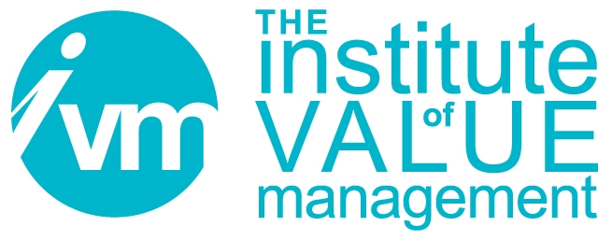

Certification Board

APPLICATION FOR THE QUALIFICATION:
CERTIFIED VALUE SPECIALIST (CVS)
UNDER THE SAVE INTERNATIONAL – VALUE FOR EUROPE BOARD
COLLABORATIVE AGREEMENT
FOR HOLDERS OF PROFESSIONAL IN VALUE MANAGEMENT (PVM) QUALIFICATION

The Institute of Value Management is a company limited by guarantee in England and Wales.
Registered Office Office - Unit 19, The Manor, Main Street, Tur Langton, Leicester, LE8 0PJ.
Registered No 37981

Document Control
Title | CB 111 Application for the Qualification:  Certified Value Specialist (CVS)  through reciprocity with SAVE International
Person Responsible | CB Chair
Date last updated | November 2019
Status | Final
Version | V111.2.3
This document is the property of the IVM. It shall not be reproduced in whole or part nor disclosed to a third party. © Copyright 2010 IVM

SECTION 1 – Applicant’s details
Title and Name:
Contact Address:
Phone: Fax: Mobile phone:
E mail address:
PVM certificate number: Date PVM awarded:
PVM Expiration date:

SECTION 2 – Endorsement and advisor details

Name of endorser:

Position of endorser within V4E Board/NCO:

Contact e mail of endorser:
I support this application and confirm the validity of information supplied.

Signature of endorser: Date:

Name of advisor (optional):

Contact e mail of advisor:

SECTION 3 – Other Additional requirements

A: I am attaching the CVS Board approved Professional Experience Log.

All the experience listed in the Log is less than 4 years old.

The Total Contact Hours is for full team involvement only:

The Total Facilitator Hours is for lead or co-facilitating only:

B: I have created a minimum of two FAST Diagrams as lead or co-facilitator

These FAST Diagrams are consistent with the SAVE International Standards.
I hereby certify that the above information is true.

Applicant’s signature: Date:
Once filled and signed, this form should be sent to:
Les Thomas, PE, CVS, Administrator Certification Board
3460, Pointview Circle
Gainsville, GA, 30506, USA
or electronically to: lthomaspe@aol.com
followed by mail forwarding of originals or scanned copy.

Supporting documents to be included:
Copy of PVM certificate
Professional Experience Log
Two examples of FAST Diagrams (according to Section 3B)
Short Bio or Resume
Registration fee of $ (to be verified with SAVE International)

