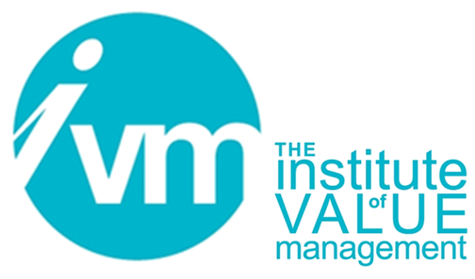

**Personal Declaration**

**relating to an application**

**for the V4E QVA Qualification**

**CONTROLLED DOCUMENT**

The Institute of Value Management is a Company limited by guarantee. Registered in England No 3798199

Registered Office: Unit A, 82 James Carter Road, Mildenhall, Suffolk, England IP28 7DE

|  |  |
| --- | --- |
| **Document Control** | |
| **Title** | Personal Declaration relating to an application for the V4E QVA Qualification |
| Person Responsible | CB Chair |
| Date last updated | April 2024 |
| Status | FINAL APPROVED FOR ISSUE |
| Version | 1.1 |
| This document is the property of the IVM. It shall not be reproduced in whole or part nor disclosed to a third party. © Copyright 2023 IVM | |

**Personal Declaration**

I, the undersigned, confirm that:

1. Having completed a Value for Europe (V4E) Value Management VM1 course, I wish to progress to the QVA qualification. I note that I will be required to be successful in the QVA examination and participate in 2 VM studies and then complete my application for the QVA qualification using CB Form 107.
2. I am returning this signed personal declaration of intent (CB Form 107-PD) to the IVM Secretary ([secretary@ivm.org.uk](mailto:secretary@ivm.org.uk)) and confirm that payment of the £150 QVA application fee has been paid to:   
    Institute of Value Management,   
    Lloyds Bank Sort Code 30-94-38, Account No: 00409451   
    IBAN Number: GB41LOYD30943800409451,   
    Quoting Payment Reference as my name below
3. I understand that when receipt of this declaration and the payment are notified to the IVM Certification Board (CB), the CB will instruct the IVM Secretary to allocate me a Unique QVA Application Reference Number and I will be invited by the CB to sit the QVA exam, which is to be held at [Time, Date and Venue] to be advised by my Trainer (Trainer in Value Management).
4. I also understand that the QVA exam paper will receive a preliminary marking by the TVM running the exam session. The TVM will liaise with a CB Assessor for confirmation of that marking and where appropriate, the issue of an IVM CB certificate confirming passing the QVA exam.
5. I understand that on confirmation of passing the QVA exam, I will receive the final application form for the QVA qualification (CB107), with no further payment required – and **I note** **all four requirements that are needed to complete the form**, the VM1 course and QVA exam certificates, plus participation in 2 VM studies.
6. I have received, from my Trainer (TVM), details of CB107, requiring a short CV and short summaries of two VM studies.
7. I understand that the £150 application fee for the QVA qualification is non-refundable.
8. I consent to the Trainer in Value Management (TVM) course provider and the IVM Certification Board retaining the information contained in this completed form for their use in connection with the Value for Europe Value Management Training and Certification System (V4E-TCS) and Institute of Value Management (IVM) Certification Board matters respectively.

|  |  |
| --- | --- |
| Signed: |  |
| Print Name (in full): |  |
| Email address |  |
| Date: |  |