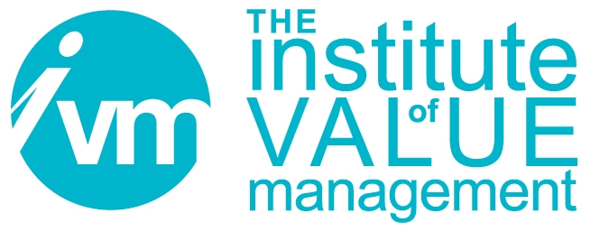

Certification Board

APPLICATION FOR
THE PROFESSIONAL IN VALUE MANAGEMENT (PVM) QUALIFICATION
UNDER THE SAVE INTERNATIONAL – EGB/V4E VALUE FOR EUROPE BOARD COLLABORATIVE AGREEMENT
[CVS HOLDERS ONLY]

CONTROLLED DOCUMENT

The Institute of Value Management is a Company limited by guarantee. Registered in England No 3798199
Registered Office: Unit A, 82 James Carter Road, Mildenhall, Suffolk, England, IP28 7DE

Document Control
Title | CB 110 Application for the Professional in Value Management (PVM) Under the SAVE International – EGB/V4E Value for Europe Board Collaborative Agreement [CVS Holders Only]
Person Responsible | CB Chair
Date last updated | April 2025
Status | FINAL APPROVED Issued for Use
Version | 13.3
This document is the property of the IVM. It shall not be reproduced in whole or part nor disclosed to a third party. © Copyright 2010 IVM

SAVE INTERNATIONAL – EGB/V4E BOARD Collaborative Agreement

Application form for holders of a CVS to become a PVM

SECTION 1 – Applicant’s details

Title and Name:

Contact Address:

Phone: Fax: Cell phone:

E mail address:

CVS certificate number: Date CVS awarded:

CVS Expiration date:

SECTION 2 – Endorsement and Advisor details

Name of Endorser:

Position of Endorser within SAVE International:

Contact e-mail of Endorser:
I support this application and confirm the validity of information supplied.

Signature of Endorser: Date:

Name of Advisor(optional):

Contact e-mail of Advisor:

SECTION 3 – Understanding the European Standard
I affirm that I have read the EN 12973:2020 Value Management Standard and understand how it differs from relevant SAVE International standards or recommended SAVE International practice.

SECTION 4 – Other Additional requirements

Please complete either part A or B

A: I have attended a VM Module 3 (VM3) course in Value Management, approved by the V4E Board, previously known as the EGB.

The course was run on by

I have enclosed a copy of the course certificate

B: I have completed either 3 one-day seminars or classes in a relevant subject, or I have authored 3 papers in a refereed publication, or a combination of the two.

Seminars/Classes
- Title/description: Duration:

Instructor’s name and qualifications:

Supplying organisation: Awarding Organization:

Part of Degree Course

2 Title/description: Duration:

Instructor’s name and qualifications:

Supplying organisation: Awarding Organization:

Part of Degree Course

3 Title/description: Duration:

Instructor’s name and qualifications:

Supplying organisation: Awarding Organization:

Part of Degree Course

Papers or Book Chapters (One in each major area)
- Co-author(s): Date of Publication:

Title:

Journal/ Publisher:
- Co-author(s): Date of Publication:

Title:

Publication/Journal:
- Co-author(s): Date of Publication:

Title:

Publication/Journal:
I, hereby certify that the above information is true.

Applicant’s signature: Date:
Once filled and signed, this form should be sent to:
The Secretary, the Institute of Value Management
Unit A, 82 James Carter Road, MILDENHALL, SUFFOLK, IP28 7DE, UK.
or electronically to: secretary@ivm.org.uk.
followed by mail forwarding of originals.

Supporting documents to be included:
Copy of CVS certificate.
Copy of VM3 course attendance certificate, where appropriate.
Letter of justification where appropriate for courses/seminars that do not meet specified requirements.
Syllabus of courses attended.
Copy of papers where appropriate.
Short CV or resume (1 page).
Registration fee of GBP£X (equivalent to €500.00)

