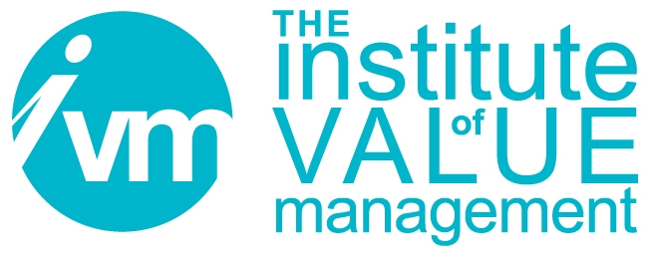

Certification Board

APPLICATION FOR
THE CERTIFIED VALUE SPECIALIST (CVS) QUALIFICATION
UNDER THE SAVE INTERNATIONAL – EGB/V4E VALUE FOR EUROPE BOARD COLLABORATIVE AGREEMENT
[PVM HOLDERS ONLY]

CONTROLLED DOCUMENT

The Institute of Value Management is a Company limited by guarantee. Registered in England No 3798199
Registered Office: Unit A, 82 James Carter Road, Mildenhall, Suffolk, England IP28 7DE

Document Control
Title | CB 111 Application for the Certified Value Specialist (CVS) Under the SAVE International – EGB/V4E Value for Europe Board Collaborative Agreement [PVM Holders Only]
Person Responsible | CB Chair
Date last updated | April 2025
Status | FINAL APPROVED Issued for Use
Version | 13.3
This document is the property of the IVM. It shall not be reproduced in whole or part nor disclosed to a third party. © Copyright 2010 IVM

SAVE INTERNATIONAL – EGB/V4E BOARD Collaborative Agreement

Application form for holders of a PVM to become a CVS

SECTION 1 – Applicant’s details
Title and Name:
Contact Address:
Phone: Fax: Mobile phone:
E mail address:
PVM certificate number: Date PVM awarded:
PVM Expiration date:

SECTION 2 – Endorsement and Advisor details

Name of Endorser:

Position of Endorser within EGB/V4E/NCO:

Contact e-mail of Endorser:
I support this application and confirm the validity of information supplied.

Signature of Endorser: Date:

Name of Advisor (optional):

Contact e-mail of Advisor:

SECTION 3 – Other Additional requirements (see www.value-eng.org for these):

A: I am attaching the CVS Board approved Professional Experience Log.

All the experience listed in the Log is less than 4 years old.

The Total Contact Hours is for full team involvement only:

The Total Facilitator Hours is for lead or co-facilitating only:

B: I have created a minimum of two FAST Diagrams as lead or co-facilitator

These FAST Diagrams are consistent with the SAVE International Standards.

I, hereby certify that the above information is true.

Applicant’s signature: Date:

Once filled and signed, this form should be sent electronically to:
SAVE International, see www.value-eng.org for CVS Application steps.
followed by mail forwarding of originals or scanned copy.

Supporting documents to be included:
Copy of PVM certificate.
Professional Experience Log.
Two examples of FAST Diagrams (according to Section 3B.
Short Bio or Resume.
Fees are stated on the SAVE International website www.value-eng.org

